Week .1
Course Name : Problem Solving and Testing
Course Code : 10211CS227
Name : M.Surya Vamshi
Vtu No : Vtu27544

Session 1 :
1.Java Lambda Expressions.
Session 2 :
1.Java Sort.
2.Sort Array By Parity.
Session 3 :
1.Sorting:Comparator.
2.Java Comparator.
Session 4 :
1.Running Sum of ID Array.
2.Richest customer Wealth.
Session 5 :
1.Squares of a Sorted Array.
2.Find Pivot Index.

Session 1 :
1.Java Lambda Expressions.
PROGRAM :

import java.util.*;

interface PerformOperation {
boolean check(int a);
}

class MyMath {

public PerformOperation isOdd() {
return n -> n % 2 != 0;
}

public PerformOperation isPrime() {
return n -> {
if (n < 2) return false;
for (int i = 2; i * i <= n; i++) {
if (n % i == 0) return false;
}
return true;
};
}

public PerformOperation isPalindrome() {
return n -> {
int rev = 0, temp = n;
while (temp > 0) {
rev = rev * 10 + temp % 10;
temp /= 10;
}
return rev == n;
};
}

public boolean checker(PerformOperation p, int num) {
return p.check(num);
}
}

public class Solution {
public static void main(String[] args) {
Scanner sc = new Scanner(System.in);
MyMath ob = new MyMath();

int T = sc.nextInt();

while (T-- > 0) {
int ch = sc.nextInt();
int num = sc.nextInt();

if (ch == 1)
System.out.println(ob.checker(ob.isOdd(), num) ? "ODD" : "EVEN");
else if (ch == 2)
System.out.println(ob.checker(ob.isPrime(), num) ? "PRIME" : "COMPOSITE");
else
System.out.println(ob.checker(ob.isPalindrome(), num) ? "PALINDROME" : "NOT PALINDROME");
}

sc.close();
}
}
OUTPUT :
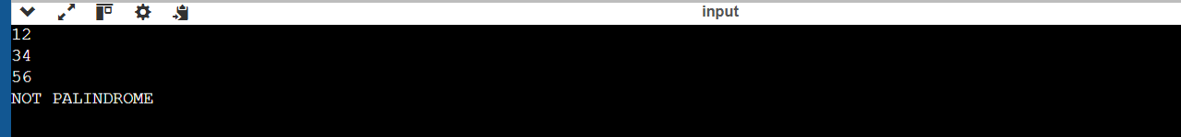

Session 2 :
1.Java Sort.

PROGRAM :
import java.util.*;

class Student {
private int id;
private String fname;
private double cgpa;

public Student(int id, String fname, double cgpa) {
this.id = id;
this.fname = fname;
this.cgpa = cgpa;
}

public int getId() {
return id;
}

public String getFname() {
return fname;
}

public double getCgpa() {
return cgpa;
}
}

public class Solution {
public static void main(String[] args) {
Scanner in = new Scanner(System.in);
int testCases = Integer.parseInt(in.nextLine());

List<Student> studentList = new ArrayList<>();

while (testCases-- > 0) {
int id = in.nextInt();
String fname = in.next();
double cgpa = in.nextDouble();

Student st = new Student(id, fname, cgpa);
studentList.add(st);
}

Collections.sort(studentList, (s1, s2) -> {
if (Double.compare(s2.getCgpa(), s1.getCgpa()) != 0) {
return Double.compare(s2.getCgpa(), s1.getCgpa());
}
if (!s1.getFname().equals(s2.getFname())) {
return s1.getFname().compareTo(s2.getFname());
}
return Integer.compare(s1.getId(), s2.getId());
});

for (Student s : studentList) {
System.out.println(s.getFname());
}

in.close();
}
}

OUTPUT :

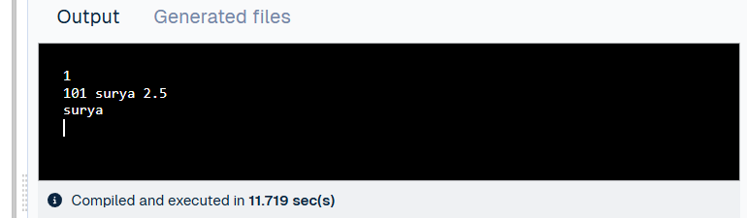
2.Sorted Array by Parity.

PROGRAM :
class Solution {
public int[] sortArrayByParity(int[] nums) {
int[] result = new int[nums.length];
int index = 0;

// Add even numbers first
for (int num : nums) {
if (num % 2 == 0) {
result[index++] = num;
}
}

// Add odd numbers
for (int num : nums) {
if (num % 2 != 0) {
result[index++] = num;
}
}

return result;
}
}

OUTPUT: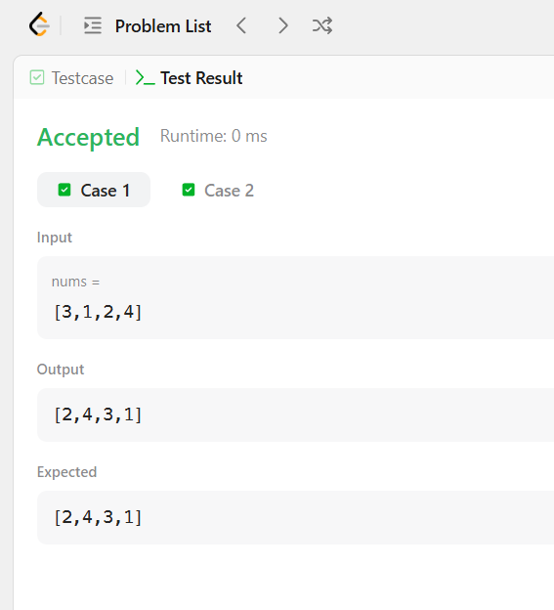

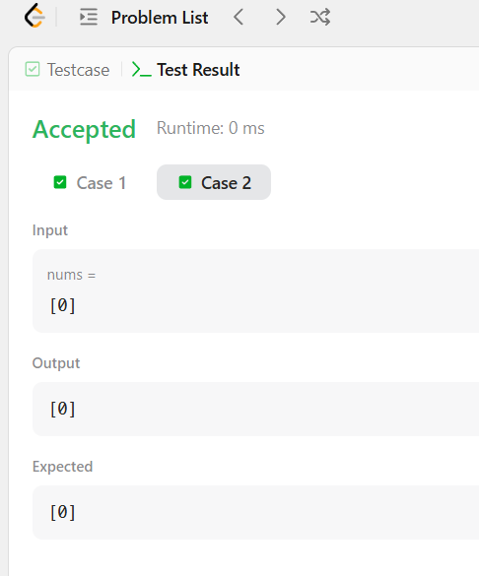

Session 3 :
1.Sorting : Comparator.

PROGRAM :
import java.util.*;

class Player {
String name;
int score;

Player(String name, int score) {
this.name = name;
this.score = score;
}
}

class Checker implements Comparator<Player> {

@Override
public int compare(Player a, Player b) {
if (a.score != b.score) {
return b.score - a.score; // Descending score
}
return a.name.compareTo(b.name); // Ascending name
}
}

public class Solution {
public static void main(String[] args) {
Scanner sc = new Scanner(System.in);

int n = sc.nextInt();
Player[] player = new Player[n];

for (int i = 0; i < n; i++) {
player[i] = new Player(sc.next(), sc.nextInt());
}

Arrays.sort(player, new Checker());

for (Player p : player) {
System.out.println(p.name + " " + p.score);
}

sc.close();
}
}
OUTPUT : 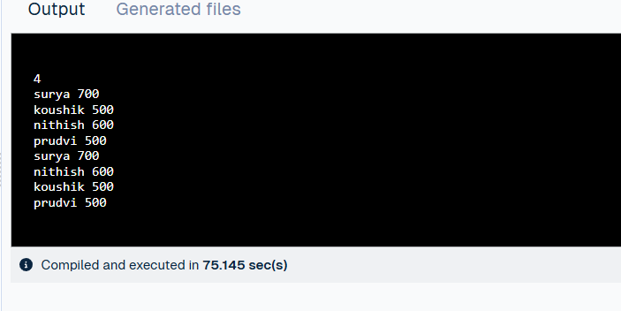

2.Java Comparator.

PROGRAM :
import java.util.*;

class Player {
String name;
int score;

Player(String name, int score) {
this.name = name;
this.score = score;
}
}

class Checker implements Comparator<Player> {
@Override
public int compare(Player a, Player b) {
if (a.score != b.score)
return b.score - a.score;
return a.name.compareTo(b.name);
}
}

public class Solution {
public static void main(String[] args) {
Scanner sc = new Scanner(System.in);

int n = sc.nextInt();
Player[] player = new Player[n];

for (int i = 0; i < n; i++) {
player[i] = new Player(sc.next(), sc.nextInt());
}

Arrays.sort(player, new Checker());

for (Player p : player) {
System.out.println(p.name + " " + p.score);
}

sc.close();
}
}

OUTPUT :
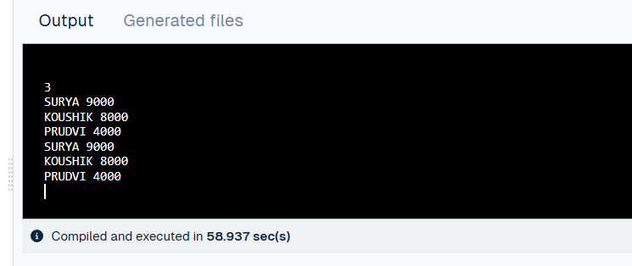

Session 4:
1.Running Sum of ID Array.

PROGRAM :
class Solution {
public int[] runningSum(int[] nums) {
for (int i = 1; i < nums.length; i++) {
nums[i] = nums[i] + nums[i - 1];
}
return nums;
}
}

OUTPUT :
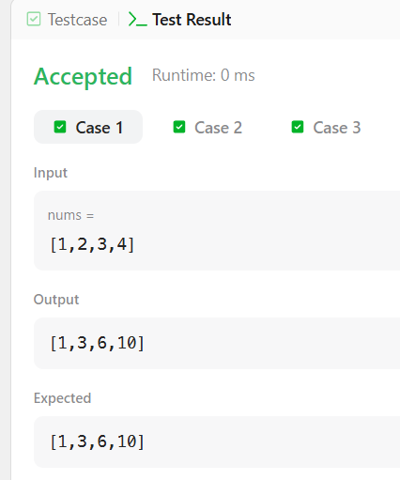

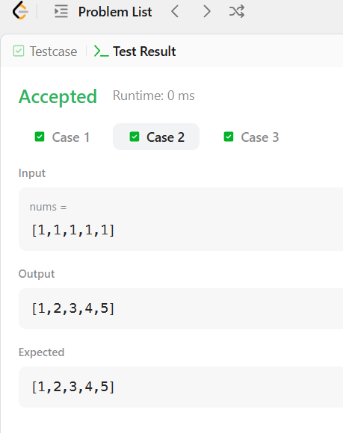

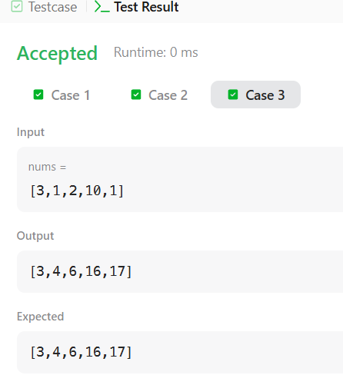

2.Richest Customer Wealth.

PROGRAM :
class Solution {
public int maximumWealth(int[][] accounts) {
int maxWealth = 0;

for (int i = 0; i < accounts.length; i++) {
int sum = 0;
for (int j = 0; j < accounts[i].length; j++) {
sum += accounts[i][j];
}
if (sum > maxWealth) {
maxWealth = sum;
}
}

return maxWealth;
}
}

OUTPUT :
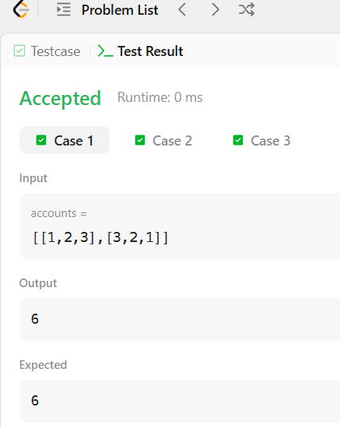

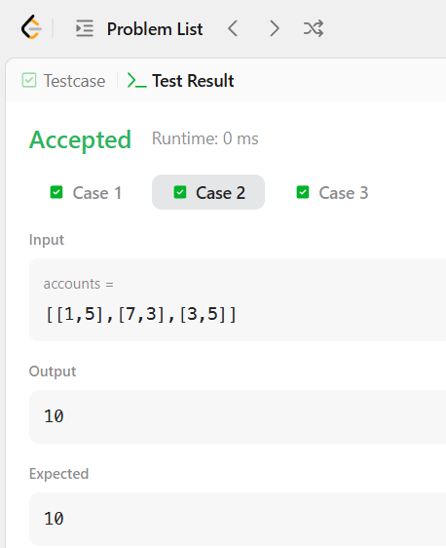

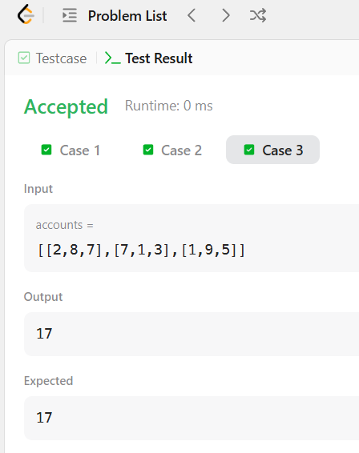

Session 5 :
1.Squares of a Sorted Array.

PROGRAM :
class Solution {
public int[] sortedSquares(int[] nums) {
int n = nums.length;
int[] result = new int[n];

int left = 0;
int right = n - 1;
int index = n - 1;

while (left <= right) {
if (Math.abs(nums[left]) > Math.abs(nums[right])) {
result[index] = nums[left] * nums[left];
left++;
} else {
result[index] = nums[right] * nums[right];
right--;
}
index--;
}

return result;
}
}
OUTPUT :
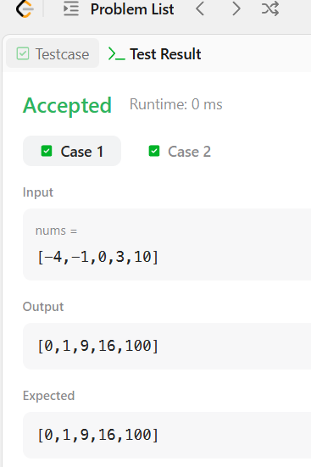

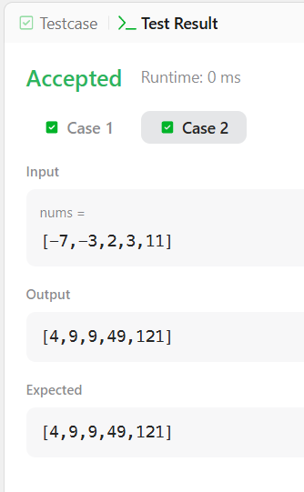
2.Find Pivot Index.

PROGRAM :
class Solution {
public int pivotIndex(int[] nums) {
int total = 0;

// Calculate total sum
for (int num : nums) {
total += num;
}

int leftSum = 0;

// Find pivot index
for (int i = 0; i < nums.length; i++) {
if (leftSum == total - leftSum - nums[i]) {
return i;
}
leftSum += nums[i];
}

return -1;
}
}

OUTPUT :
